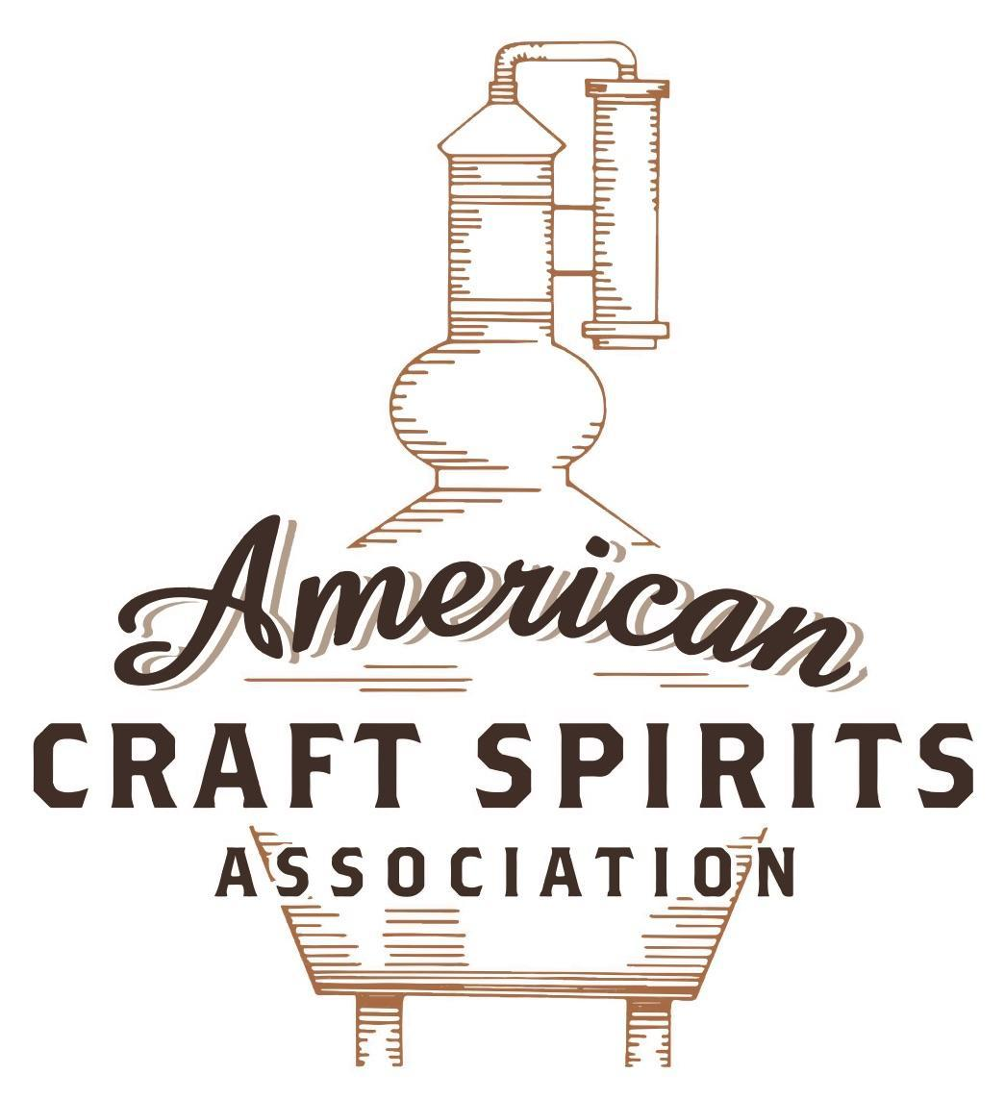
Spirits DtC Shipping Guide

This guide summarizes the direct-to-consumer shipping rules for distilleries in all 50 states and D.C. and also addresses the measures state governments have taken to ease delivery and shipping restrictions during the COVID-19 pandemic.

DtC Quick Guide Comparison

Out-of-State Distilleries  Can Ship Into State? |  |  |  | In-State Distilleries  Can Ship Within State?
State | Yes | No |  | State | Yes | No
AL |  | X |  | AL |  | X
AK | X |  |  | AK | X
AZ | X |  |  | AZ | X
AR |  | X |  | AR |  | X
CA |  | X* |  | CA |  | X*
CO |  | X |  | CO |  | X
CT |  | X* |  | CT |  | X
DE |  | X |  | DE |  | X
DC | X |  |  | DC | X
FL |  | X |  | FL |  | X
GA |  | X |  | GA |  | X
HI |  | X* |  | HI |  | ?*
ID |  | X |  | ID |  | X
IL |  | X* |  | IL |  | X*
IN |  | X |  | IN |  | X
IA |  | X* |  | IA |  | X*
KS |  | X |  | KS |  | X
KY | X |  |  | KY | X
LA |  | X |  | LA |  | X
ME |  | X* |  | ME |  | X*
MD |  | X |  | MD |  | X
MA |  | X |  | MA |  | X
MI |  | X |  | MI |  | X
MN |  | X |  | MN |  | X
MS |  | X |  | MS |  | X
MO |  | X |  | MO |  | X
MT |  | X |  | MT |  | X
NE | X |  |  | NE | X
NV |  | X* |  | NV |  | X
NH | X |  |  | NH |  | X*
NJ |  | X* |  | NJ |  | X*
NM |  | X |  | NM |  | X
NY |  | X* |  | NY |  | X*
NC |  | X |  | NC |  | X
ND | X |  |  | ND | X
OH |  | X |  | OH |  | X
OK |  | X |  | OK |  | X
OR |  | X |  | OR | X
PA |  | X* |  | PA |  | X
RI |  | X* |  | RI |  | X
SC |  | X |  | SC |  | X
SD |  | X |  | SD |  | X
TN |  | X |  | TN |  | X
TX |  | X |  | TX |  | X
UT |  | X |  | UT |  | X
VT |  | X |  | VT |  | X
VA |  | X |  | VA |  | X
WA |  | X* |  | WA | X
WV |  | X* |  | WV |  | X*

WI |  | X |  | WI |  | X
WY |  | X |  | WY |  | X

Notes:
*CA: If passed and signed into law, Senate Bill 620 would allow licensed distilled spirits producers in states other than California and licensed distilled spirits manufacturers or craft distillers in California who obtain distilled spirits direct shipper permits to ship directly to consumers in California
*CT: Consumers with appropriate permit may receive alcohol shipments
*HI: Consumers with appropriate permit may receive alcohol shipments; If passed and signed into law, Senate Bill 65 would allow licensed distilled spirits manufacturers in Hawaii and in states other than Hawaii who obtain direct shipper permits to ship directly to consumers in Hawaii
*IL: If passed and signed into law, Senate Bill 0532 would allow licensed distilled spirits producers in Illinois and in states other than Illinois who obtain distillery shippers’ licenses to ship directly to consumers in Illinois
*IA: If passed and signed into law, House File 639 would allow native distilled spirits manufacturers in Iowa and in states other than Iowa who obtain direct shipper permits to ship directly to consumers in Iowa and to consumers in states other than Iowa
*ME: If passed and signed into law, Legislative Document 1358 would allow distilleries outside of Maine with current manufacturer licenses and distilleries licensed in Maine who obtain spirits direct shipper licenses to ship directly to consumers in Maine
*NJ: (1) If passed and signed into law, Assembly Bill 3167 would allow a craft distillery licensees to ship no more than 9 liters of distilled spirits to a consumer in New Jersey; (2) If passed and signed into law, Senate Bill 3020 would allow craft distillery licensees in New Jersey or in states other than New Jersey to ship no more than 20 liters of distilled spirits to a consumer in New Jersey via common carrier
*NV: Licensed individuals can import one gallon per month of spirits for personal use and the out-of-state supplier must pay excise tax
*NH: If passed and signed into law, Senate Bill 125 would allow licensed liquor manufacturers who obtain direct to consumer shipping permits from the commission to ship directly to consumers in New Hampshire
*NY: Consumer may import up to 90L of liquor per year for personal use without a license; If passed and signed into law, Assembly Bill 3275 would allow licensed liquor manufacturers in states other than New York and licensed distillers and farm distillers in New York to ship no more than thirty-six cases (no more than nine liters per case) of liquor to consumers in New York
*PA: Consumer may place a special liquor order and distiller must ship to a PLCB-operated store
*RI: Distiller can only ship to customer if order was personally placed by customer at distiller's premises
*WA: If passed and signed into law, House Bill 1432 would allow licensed spirits manufacturers in states other than Washington to ship spirits to consumers in Washington
*WV: Distilleries, mini-distilleries, or micro-distilleries licensed in West Virginia or a state other than West Virginia who obtain private direct shipper licenses to ship to a consumer in West Virginia, however the shipments must be made to a retail liquor outlet

ARIZONA

Shipment Outbound – Yes, if permitted by the purchaser’s state (A.R.S. § 4-205.10(C)(7)(e)).

Shipment Inbound – Yes, with an Out-of-state Craft Distillery License (Series 2D).

Shipment Intra-state – Yes, with an In-state Craft Distillery License (Series 18).

COVID-19 Measures – Since AZ allows for direct-to-consumer shipping, there was no need to create additional shipping permissions. AZ allowed licensees that were shut down to provide pick-up, delivery, or drive-thru options for sealed alcoholic beverages. The AZ Department of Liquor Licenses and Control (“DLLC”) considered the sale of spirituous liquor by non-restaurant retailers with off-sale privileges under A.R.S. § 4-209(B) using pick-up, delivery, or drive-thru options as a delivery of alcohol under A.R.S. § 4-203(J) and not in violation of Executive Order 2020-09 which was issued on March 19, 2020 and was rescinded by Executive Order 2021-06. The legislature of Arizona passed H.B. 2773 that was signed into law on May 5, 2021. This legislation authorizes a holder of a retail license with off-sale privileges to deliver spirituous liquor to a person in Arizona.
Executive Order 2020-09 Guidance Link: https://azliquor.gov/assets/documents/homepage_docs/Governors_EO%202020-9.pdf
Executive Order 2021-06 Link:
https://azgovernor.gov/sites/default/files/eo_2021-06.pdf
H.B. 2773 Link:
https://www.azleg.gov/legtext/55leg/1r/laws/0375.pdf
Citation (shipment)
Arizona Revised Statutes
A.R.S. § 4-205.10. Craft distiller license; issuance; regulatory provisions; fee.
C. A person may be licensed as a craft distiller to sell distilled spirits that are produced or manufactured by the person if in a calendar year the person produces or manufactures not more than twenty thousand gallons of distilled spirits and may make sales and deliveries of distilled spirits only as specified in this section and subject to the following criteria:
7. A licensed craft distiller may make sales and deliveries of distilled spirits that the licensed craft distiller manufactures or produces to consumers off of the licensed premises if the sale or delivery is ordered by telephone, mail, fax, catalogue, the internet or by other means if all of the following conditions exist:
(a) The purchaser of the distilled spirits provided the licensed craft distiller with verification of the purchaser’s legal age to purchase alcohol and a copy of same is maintained in the records of the craft distiller.
(b) The shipping container in which the distilled spirits are shipped is marked to require the signature on delivery of an adult who is of legal age to purchase alcohol and delivery confirmation.
(c) The distilled spirits are for personal use only and not for resale.
(d) The distilled spirits are shipped to a residential or business address other than a premises licensed pursuant to this title.
(e) The purchaser could have carried the distilled spirits lawfully into or within this state.
(f) A person who is at least twenty-one years of age makes the delivery.
(g) The craft distiller collects payment for the price of the spirituous liquor no later than at the time
of delivery.
A.R.S. § 4-250.01. Out-of-state person engaged in business as producer, exporter, importer or rectifier; violation; cease and desist order; civil penalty
A. An out-of-state person engaged in business in this state as a producer, exporter, importer, rectifier, retailer or wholesaler without a license issued under this title shall comply with this title as if licensed by this state.
Link to Arizona Liquor Laws and Shipping Guide:
https://azliquor.gov/assets/documents/Title%204%20Law%20Book/2020_Title4Book.pdf
https://www.azliquor.gov/faq/internet_sales.cfm

Arizona Liquor License Application Kits:

Out-of-state Craft Distiller Application Kit (Series 02D)
An Out-of-state Craft Distillery produces not more than 20,000 gallons of distilled spirits annually.

This license has on- and off-sale retail privileges. The licensee may serve spirits produced on the premises for consumption on the premises, sampling, and in the original, sealed container for sales “to-go”. The licensee may sell and deliver to consumers who order by telephone, mail, fax, catalogue or internet per A.R.S. §4-205.10(7).
Link: https://www.azliquor.gov/series02D.cfm

In-state Craft Distillery Application Kit (Series 18)
An In-state Craft Distillery is located in Arizona and produces not more than 20,000 gallons of distilled spirits annually.

This license has on- and off-sale retail privileges. The licensee may serve spirits produced on the premises for consumption on the premises, sampling, and in the original, sealed container for sales “to-go”. The licensee may sell and deliver to consumers who order by telephone, mail, fax, catalogue or internet per A.R.S. §4-205.10(7).
Link: https://www.azliquor.gov/series18.cfm

The American Craft Spirits Association (ACSA) is working diligently to give our members and industry partners relevant, current updates on statutes and regulations impacting production, sale and distribution of spirits. With the declaration of the novel coronavirus (COVID-19) in early 2020, many states have issued temporary policy changes or longer-term modernization of alcohol beverage laws. State statutes, regulations created by the state alcohol regulatory authority, as well as any other relevant guidance provided by such authorities (such as advisories, opinions, bulletins, etc.) were reviewed in creation of this document. No city or county ordinances were reviewed. Distillers should be aware that even in states where direct shipping is permissible, always remember to avoid shipping to dry counties. Please consult with your state guild or alcohol beverage authority for the most up-to-date information. This content is intended for educational and informational purposes only. ACSA's pro bono law firm of Malkin Law P.A. provided the core content found in this comprehensive overview of the spirits distribution after COVID-19. It was completed in August 2021 and will be updated regularly. If you have updates you would like to provide, please send to legislation@americancraftspirits.org or directly to the law firm at: ryan@malkin.law / malkin.law. Thank you.

